

Carbon Emissions
Statement

Selby Trust
Selby Rd, London
N17 8JL

Version 1.0
July 2023

Report details
Client | Selby Trust (General Info – 14C)
Report title | Carbon Emission Statement
Site Address | Selby Rd, London N17 8JL (General Info – 14C)
Project Number | CBT19806

Document control
Issue | Issue Date | Purpose of report | Author | QA | Authorized
Version 1.0 | 07/05/2023 | Draft | CT | JP | TH
Version 1.0 | 13/07/2023 | Issue | CT | JP | TH

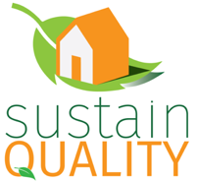

Sustain Quality Ltd | The Long Barn | Cobham Park Rd | Surrey | KT11 3NE | Tel: 01372 438 039
info@sustainquality.co.uk | www.sustainquality.co.uk | @SustainQuality | Facebook | LinkedIn

The preparation of this report by Sustain Quality Ltd (SQ) has been undertaken within the terms of the proposal using all reasonable skills and care. Sustain Quality Ltd accepts no responsibility for the data provided by other bodies and no legal liability arising from the use by other persons of data or opinions contained in this report. The wider limitations are presented in Appendix A.

Contents

Executive Summary 4
1 Introduction 5
2 Carbon Emissions Methodology 6
3 Carbon Emissions 8
3.1 Emissions boundaries 8
3.2 Limitations (Notes and Standards 15D-22D) 8
3.3 Carbon accounting 8
3.4 Baseline year 9
3.5 Performance 9
3.6 Recommendations (???? AI???) 10
4 Achieving net zero emissions 12
4.1 Data quality 12
4.2 Internal Emissions Reduction 12
4.3 External Emissions Reduction 12
4.4 Offsetting Strategies 12
5 Conclusion 14
References 15
Appendix A - Limitations 16
Appendix B - United Nations Sustainable Development Goals 17
Appendix C – Carbon Offset 20
Appendix D – Emissions Sources Classification 23

Executive Summary
This report was prepared by Sustain Quality to calculate the carbon emissions of Selby Trust (General Info – 14C) for the financial year 2022/2023 (Notes and Standards 15C).

Selby Trust (General Info – 14C) is actively working towards achieving Net Zero Carbon status by 2050, recognizing the importance of understanding the carbon emissions resulting from its business operations.

The calculation of Selby Trust (General Info – 14C)'s carbon emissions consider energy use (electricity and gas), water consumption, waste generation, and business travel (Notes and Standards 15C-22C) as the relevant sources.

Based on the provided data, this report assesses Selby Trust(General Info – 14C)'s total emissions to be 2,079.61 2024 (Results Graphs – DASHBOARD) tonnes of CO₂e, which must be offset and/or reduced to attain carbon neutrality.

Additionally, this report emphasizes the charity's dedication to the United Nations Sustainable Development Goals, which are detailed in Appendix B.

Introduction
Selby Trust is a community centre located in the London Borough of Haringey. Selby is a registered charity. It has been at the heart of the Tottenham, Haringey community for 30 years. They are learning a development centre, a vocational training centre, a workspace, a sports centre, a counselling and wellbeing resource, a community events hall and a social space, and a safety net. (General Info – 22C)

Selby Trust (General Info – 14C) is looking to become a Net Zero Carbon entity and as part of this commitment, there is a need to understand what the carbon emissions are associated with their business operations. The charity is actively working towards its target and is currently calculating carbon emissions for the 2022/2023 (Notes and Standards 15C) financial year with a 2022/2023 (Notes and Standards 13C) as a baseline year. As part of this process, there is a strong commitment to enhancing the accuracy and consistency of the dataset.

Following the Green House Gas Protocol Corporate Standard, the carbon footprint will be reported according to three scopes of emission types:

- Scope 1: Direct emissions that result from activities within your organisation’s control. This might include on-site fuel combustion, manufacturing and process emissions, refrigerant losses, and company vehicles.

- Scope 2: Indirect emissions from any electricity, heat, or steam you purchase and use. Although you’re not directly in control of the emissions, by using the energy you are indirectly responsible for the release of CO_{2.}

- Scope 3: Any other indirect emissions from sources outside your direct control. Examples of scope 3 emissions include purchased goods and services, use of sold goods, employee commuting and business travel, outsourced transportation, waste disposal, and water consumption.

The scope of this report includes the data available, which may cover Scope 1 (Gas Consumption), Scope 2 (Electricity Consumption) and Scope 3 (Water consumption & Sewage, Waste generation and Staff Commute) Notes and Standards 15C-22C). This report provides information on total carbon emissions calculated and includes details on offsetting, including the main types of standards used to offset these credits, for example, Gold Standard and Verra.

Carbon Emissions Methodology
This report describes the methodology to calculate the CO₂ emissions arising from internal operations. This methodology can be used to set up a system of monitoring and reporting, and possibly encourage a Carbon Reduction Plan to set a target to reduce its CO₂ emissions.

To calculate carbon emissions, the initial step involves defining the organizational boundary and determining which parts of the organization to gather data from. Following this, it is important to identify the specific activities within the organization that contribute to the release of CO₂ emissions into the atmosphere.

Following the Green House Gas Protocol Corporate Standard, the carbon emissions will be reported according to three scopes of emission types. Scope 1 is direct emissions, caused by activities owned or controlled by the organisation. Scope 2 and 3 are indirect emissions. See the table with categorisation below.

Table 01 - Categorisation of scopes
Scope | Carbon Emission Source | GHG Protocol Category
1 – Direct | Natural gas used for company facilities | Stationary Combustion
 | Company fleet & leased vehicles | Mobile Combustion
2 – Energy Indirect Emissions | Electricity used for company facilities (incl. cooling) | Purchased Electricity (Location- or Market-Based)
3 – Indirect Value Chain | Business travel | Category 6 – Business Travel
 | Private vehicle for business use (employee-owned vehicles used for work) | Category 6 – Business Travel
 | Staff commute | Category 7 – Employee Commuting
 | Water (consumption and wastewater) | Category 3 – Fuel- and Energy-Related Activities (not included in Scope 1 or 2)
 | Waste (household, paper, compost, energy etc) | Category 5 – Waste Generated in Operations
 | Paper waste | Category 5 – Waste Generated in Operations
 | Home working | Category 7 – Employee Commuting (Home-working methodological convention)

It is important to have a consistent calculation method to make accurate comparisons. This implies that the boundaries, scope, and reporting period of each calculation need to be consistent. There are several ways to collect and manage this activity data at a corporate level.

For example, it could include direct entry of activity data by operational staff onto secure databases or standard spreadsheet templates completed and emailed to a central point where data can be processed. Ideally, CO₂ reporting should be integrated into existing reporting tools and processes of the organisation.

A baseline year for CO₂ emissions needs to be chosen and annual targets can be set. This way the improvements of the organisation can be tracked, emission hotspots can be identified, and adjustments can be made within the organisation's operations.

In line with best practice, two emissions totals are to be reported: gross emissions and net emissions.

- To calculate “gross” emissions, we use national average conversion factors – which enables better benchmarking.

- To calculate “net” emissions, classify consumption from renewable energy as zero emissions and consider directly offset purchased services as carbon neutral.

It is recommended to report a summary table of the CO₂ emissions data for the chosen annual reporting period, the previous year’s performance, and the base year. Once you have measured and calculated your total CO₂ emissions, setting an emission reduction target is the logical next step.

The following workflow will be applied to work towards reducing CO₂ emissions. Sustain Quality will be able to carry out the calculations when the data is supplied by the organisation.
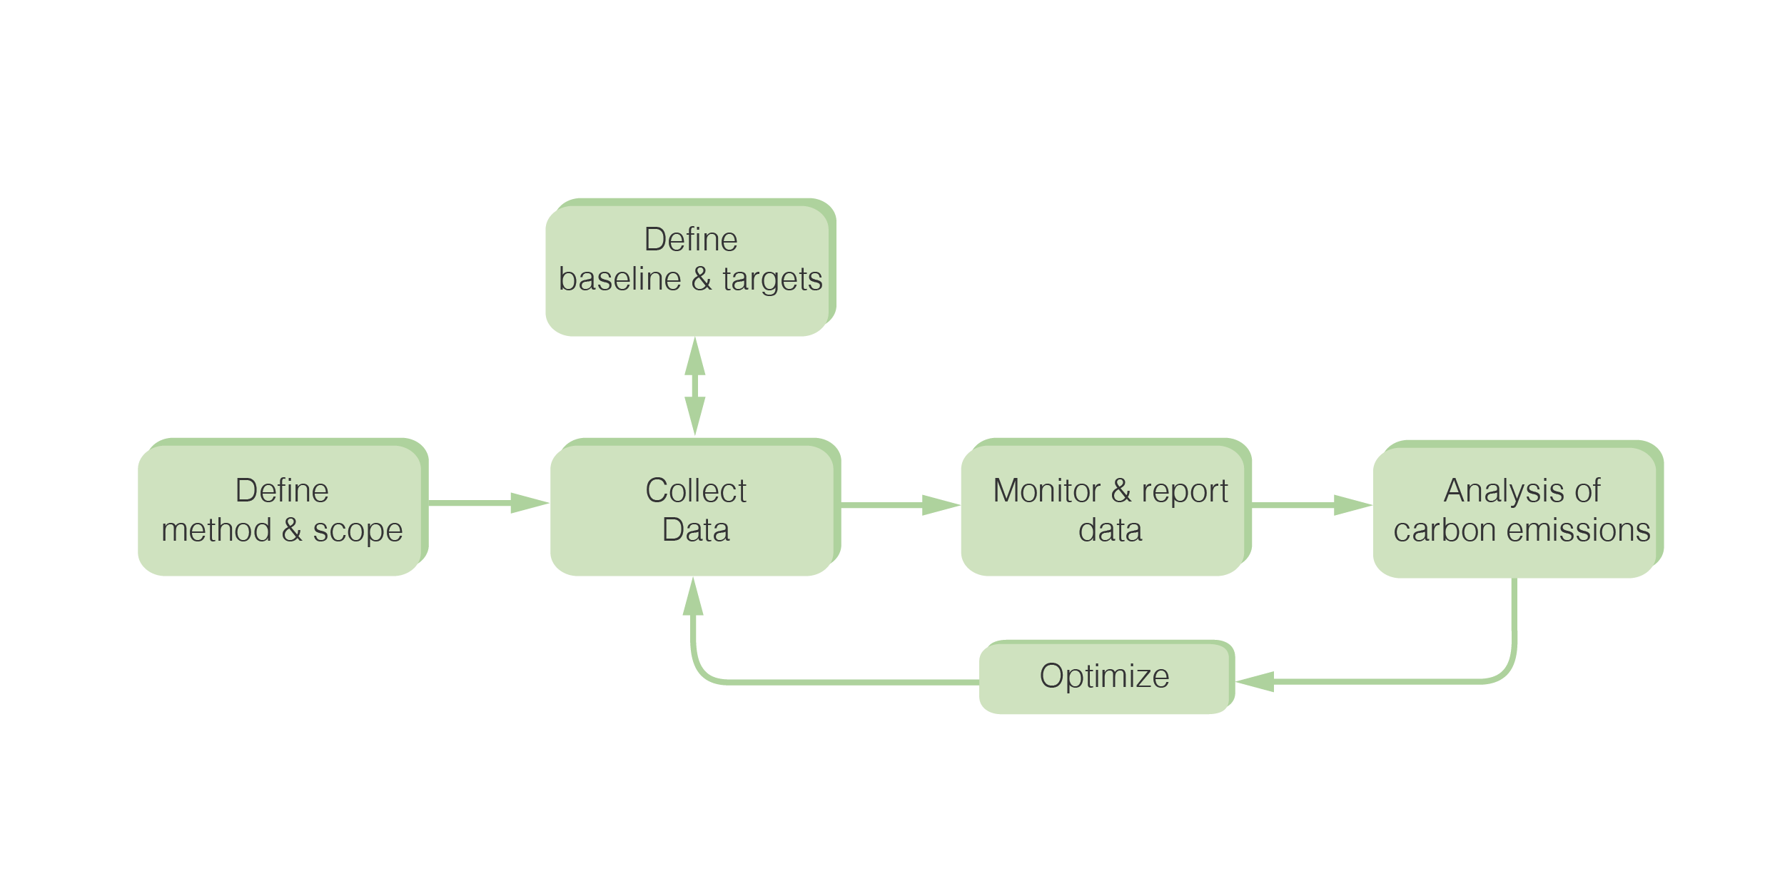

Figure 01 – Carbon Accounting Continuous improvement plan

Carbon Emissions

Emissions boundaries

The table below summarises the carbon emission boundaries. Appendix D presents a comprehensive list of emissions to consider.

Table 02 - Emissions Boundaries (Notes and Standards 15C-22C)
Quantified | Non-quantified | Not Applicable
Gas  Electricity  Waste to energy  Water consumption  Wastewater  Employee commuting | Business Travel  Paper

Limitations (Notes and Standards 15D-22D)

Paper and business travel were not quantified to a lack of information and data.

Gas consumption was estimated for the period from April 2022 to March 2023. Readings were recorded from 4 meters during April and May and from 3 meters for the remaining months.

Electricity consumption, on the other hand, was estimated based on the invoice period from March 2022 to March 2023.

Water and wastewater consumption were estimated for the period from May 2022 to April 2023.
Business Travel has been accounted for based on the information provided by Selby Trust.

Staff commuting was quantified based on the spreadsheet provided by the charity. The period of the data was not informed as well as how many days of the week the workers head to the office.

Carbon accounting

Selby Trust(General Info – 14C) is committed to data quality and to taking action to reduce the CO₂e of its operations and management. This report provides a breakdown of the CO₂e arising from their internal operations.

Baseline year

This report presents the base year as March 2022 to April 2023(Notes and Standards 13C). Data consistency is an important element of carbon emissions accounting, it helps to set targets and supports management decisions.

Performance

The CO₂e during the period mentioned above has been calculated using UK Government carbon emissions factors for the year 2022/2023 (Notes and Standards 15C). These conversion factors allow organisations and individuals to calculate GHG emissions from a range of activities, including energy use, water consumption, waste disposal and recycling, and transport activities.

Table 03 – Current Year Emissions (tCO₂e) financial year (Results Graphs – DASHBOARD)
Scope | Carbon Emission Source | Usage Data | Conversion Factor 2023 | Carbon Emissions  (tCO₂e) | Carbon Emissions  by Scope  (tCO₂e)
1 | Natural gas used for company facilities | 951,562.50  kWh | 0.18  kWh/kg CO₂e | 171.28 | 171.28
2 | Electricity used for company facilities (incl. cooling) | 564,347.10  kWh | 0.207074  k kWh/kg CO₂e | 116.86 | 116.86
3 | Business travel | - | Depending on mode | - | 1,791.46
 | Staff commute | 113.29 miles | Depending on mode | 1.30
 | Water use | 6,987 m³ | 0.149 m³/ kg CO₂e | 1.23
 | Wastewater | 6,987 m³ | 0.272 m³/ kg CO₂e | 1.41
 | Waste (landfill) | - | 446.204 t/ kg CO₂e
 | Waste (recycling) | - | 21.28 t/ kg CO₂e | -
 | Waste (energy) | 84 tonnes | 8.91 t/ kg CO₂e | 1,787.52
 | Waste (composting) | - | 8.91 t/ kg CO₂e | -
Total gross CO₂ Emissions (tCO₂e) |  |  |  |  | 2,079.61

Based on the data provided by the charity, it is concluded that the total carbon emissions for the year 2022/2023 (Notes and Standards 15C)were 2,079.61 (Results Graphs – DASHBOARD) tonnes of CO₂e.

As indicated in the table above, during the reporting period, Scope 3 emissions had the largest carbon footprint, attributed primarily to waste generation.

In addition, the graph below shows a breakdown of emissions according to the source.

Graph 1– CO₂ e breakdown according to the source (the year 2022/2023) - (Results Graphs – DASHBOARD)

According to the estimates, the main emissions were distributed within the following scopes: (Results Graphs – DASHBOARD)

- Scope 1 (8.24 %)
- Scope 2 (5.62 %)
- Scope 3 (86.14 %)

Graph 2—Emissions generated within the scopes (%)(Results Graphs – DASHBOARD)

Recommendations (???? AI???)

According to the Crown Workspace 2022 Recycling Recommendations Report:
- The Selby Trust has no recycling available for the other charities.
- 58% of them produce 1 to 2 bags of waste per week.
- Around half of this waste is made up of dry mix, recycling, and paper.

Selby Trust will start a new project related to waste strategies with the aim of:
- Reducing overall waste generation.
- Initiating a recycling plan and compost proposal.
- Educating employees, volunteers, and users of Selby Trust on waste generation and separation.

The charity should follow the recommendations proposed by Crown Workspace, including:
- Separate the waste produced.
- Purchase appropriate waste bins.
- Investing in staff and visitor awareness.

The Selby Trust has applied to London Community Energy Funding for:
- The installation of solar panels.
- The photovoltaic system will have a capacity of 62.37 kW.
- It will generate around 60,169 kWh/year.
- It will save about 29 tonnes of CO2e per year.
- The project will pay for itself in approximately 3 to 4 years.
- The solar panels will be installed on the current building and when the new building (Selby Urban Village) is constructed by 2026, the solar panels will be transferred to it.

Carbon Emissions Review

The Selby Centre (General Info – 14C)is looking to become a Net Zero Carbon entity and as part of this commitment, there is a need to understand what the carbon emissions are associated with their business operations.

This section of the report will provide the most recent carbon emissions calculations for in comparison to the baseline year, the financial year of 2022/23 Notes and Standards 13C.

The period measured in this report (financial year of 2023/2024) - Notes and Standards 15C will include data for scope 1 (gas usage), scope 2 (electricity consumption) and scope 3 (electricity transmission and distribution, water consumption, wastewater, waste to energy, and staff commuting). Notes and Standards 15C-22C)

The table below compares the current year’s emissions, calculated in this report, to the baseline emissions originally calculated for the Selby Centre.

Table 7: Baseline and current year emissions. Results Graphs – DASHBOARD)
Category | Baseline year | Current emissions
 | 2022/23 (kilograms CO₂e) | 2023/24 (kilogramsCO₂e)
Gas | 173,698.22 | 149,198.99
Electricity | 116,861.77 | 28,216.46
Water Consumption | 1,234.50 | 2,153.78
Wastewater | 1,406.61 | 2,454.07
Waste to energy | 1,787.52 | 2,149.43
Staff Commuting | 1,302.08 | 1,704.45

Figure 1: CO2 e breakdown according to the category over two financial periods. Results Graphs – DASHBOARD)

Recommendations (???? AI???)

Achieving net zero emissions
The following approach should be taken to move towards a net zero emissions organisation.

Data quality

The consistent application of accounting approaches, inventory boundaries, and calculation methodologies is essential to producing comparable CO₂e data over time. Standardised reporting is necessary, with consistency, completeness, accuracy, and transparency.

Transparency relates to the degree to which information on the processes, procedures, assumptions, and limitations of the inventory are disclosed in a clear, factual, neutral, and understandable manner based on clear documentation and archives (i.e., an audit trail). Information needs to be recorded, compiled, and analysed in a way that enables internal reviewers and external verifiers to attest to its credibility. Specific exclusions, inclusions, and assumptions need to be identified and justified, and appropriate references must be provided for the methodologies applied and the data sources used.

Internal Emissions Reduction

To reduce CO₂e, the charity can carry out projects within its operations (e.g., energy efficiency measures, installation of on-site renewables, behaviour change programmes, and supplier engagement initiatives). It is recommended that the organisation initially focuses on these reductions as they can also achieve cost savings.

The internal GHG reductions will be accounted for in your reported gross CO₂e tonne figure. Renewable electricity generated at zero emissions should be accounted for in Scope 1 and should be reported in the net CO₂e tonne figure. Recommendations on how to reduce CO₂e can be found in the Eco-Audit Report.

External Emissions Reduction

An emission reduction in their net CO₂e tonne figure can only be claimed where electricity purchased meets the ‘Good Quality’ criteria and the emission reduction reported should be based on the additional carbon saving associated with the tariff. Your electricity supplier will be able to provide you with the level of additional carbon savings achieved through their tariff.

Offsetting Strategies

Climate change is one of the biggest challenges of modern times. Most forward-thinking organisations have already started to take action to tackle climate change by reducing their carbon emissions.

Offsets have emerged as an additional way for organisations to directly reduce emissions. Carbon offsets are generated from projects that reduce the amount of greenhouse gases entering the atmosphere. To be considered an offset, the reductions achieved by a project must be additional to what would have happened in the absence of the project, a condition defined as "additionality”.

The concept of carbon neutrality, i.e., setting a set of carbon emissions within a defined limit, has emerged as an approach for some companies wishing to demonstrate their commitment to reducing emissions. The use of offsets can be an easy way to address an organisation's carbon footprint in the short term, but this strategy is only as good as the offsets purchased for these purposes. Further recommendations and projects can be found in Appendix C.

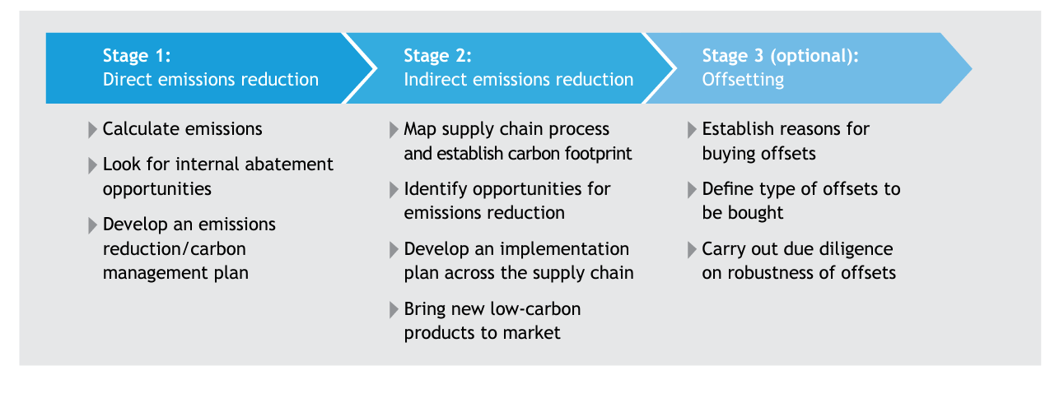
Figure 02 – Extracted from Carbon Trust offsetting strategies

Conclusion
This statement provides a summary of Selby Trust Centre(General Info – 14C)'s carbon emissions, considering Scope 1 (Gas usage), Scope 2 (Electricity use), and Scope 3 (Water use & Sewage, Waste (Energy) and Staff commutes.

The calculation period corresponds to the financial year 2022/2023(Notes and Standards 15C). This baseline year can serve as the basis for annual carbon emissions calculation, reporting, and accounting. For more details on strategies to achieve net zero, refer to the Carbon Reduction Plan Guidance.

Considering the estimates and limitations, the total carbon emissions for the baseline year (2022/2023 - (Notes and Standards 13C)) reached 2,079.61 - (Results Graphs – DASHBOARD) tonnes of CO₂e.

This report highlights Selby Trust Centre's strong aspirations for Environmental, Social, and Governance (ESG) management strategies and adherence to best practices, aligning with the expectations of visitors and clients.

Furthermore, this report underscores Selby Trust (General Info – 14C)'s commitment to Sustainable Development Goals (refer to Appendix B).

References
Carbon Trust (2022) The journey to Net Zero for SMEs. Available at: https://prod-drupal-files.storage.googleapis.com/documents/resource/public/The%20journey%20to%20Net%20Zero%20for%20SMEs%20guide.pdf

Department for Environment, Food and Rural Affairs (2009) Guidance on how to measure and report your greenhouse gas emissions. Available at:
https://assets.publishing.service.gov.uk/government/uploads/system/uploads/attachment_data/file/69282/pb13309-ghg-guidance-0909011.pdf

WRI and WBCSD (2004) GHG Protocol Corporate Accounting and Reporting Standard. Available at: https://ghgprotocol.org/corporate-standard
https://ghgprotocol.org/standards/scope-3-standard

Technical Standard can be found at: https://assets.publishing.service.gov.uk/government/uploads/system/uploads/attachment_data/file/991625/PPN_0621_Technical_standard_for_the_Completion_of_Carbon_Reduction_Plans__2_.pdf

Guidance can be found at: https://assets.publishing.service.gov.uk/government/uploads/system/uploads/attachment_data/file/991623/Guidance_on_adopting_and_applying_PPN_06_21___Selection_Criteria___3_.pdf

Procurement Policy Note 06/21 can be found at:
https://www.gov.uk/government/publications/procurement-policy-note-0621-taking-account-of-carbon-reduction-plans-in-the-procurement-of-major-government-contracts

BEIS Gov UK Conversion Factor
https://ghgprotocol.org/standards/scope-3-standard

Science-Based Standard:
https://sciencebasedtargets.org/net-zero

Carbon Offset Guide can be found at:
https://www.offsetguide.org/understanding-carbon-offsets/carbon-offset-projects/

SECR – Streamlined Energy and Carbon Reporting can be found at:
https://www.gov.uk/government/publications/academy-trust-financial-management-good-practice-guides/streamlined-energy-and-carbon-reporting

Briefing Report: Putting a Price on Carbon can be found at:
https://juliesbicycle.com/resource/briefing-report-putting-a-price-on-carbon/

IPCC – AR6 Synthesis Report can be found at:
https://www.ipcc.ch/report/ar6/syr/

Appendix A - Limitations
The recommendations contained in this Report represent Sustain Quality professional opinions, based upon the information listed in the Report, exercising the duty of care required of an experienced Environmental Consultant. Sustain Quality does not warrant or guarantee that the Site is free of hazardous or potentially hazardous materials or conditions.

Sustain Quality obtained, reviewed, and evaluated information in preparing this Report from the Client and others. Sustain Quality conclusions, opinions and recommendations have been determined using this information. Sustain Quality does not warrant the accuracy of the information provided to it and will not be responsible for any opinions which Sustain Quality have expressed or conclusions that it has reached in reliance upon the information that is subsequently proven to be inaccurate.

This Report was prepared by Sustain Quality for the sole and exclusive use of the Client and for the specific purpose for which Sustain Quality was instructed. Nothing contained in this Report shall be construed to give any rights or benefits to anyone other than the Client, Sustain Quality and all duties and responsibilities undertaken are for the sole and exclusive benefit of the Client and not for the benefit of any other party.

Sustain Quality does not intend, without its written consent, for this Report to be disseminated to anyone other than the Client or to be used or relied upon by anyone other than the Client. Use of the Report by any other person is unauthorised and such use is at the sole risk of the user. Anyone using or relying upon this Report, other than the Client, agrees by its use to indemnify and hold harmless Sustain Quality from and against all claims, losses, and damages (of whatsoever nature and howsoever or whensoever arising), arising out of or resulting from the performance of the work by the Consultant.

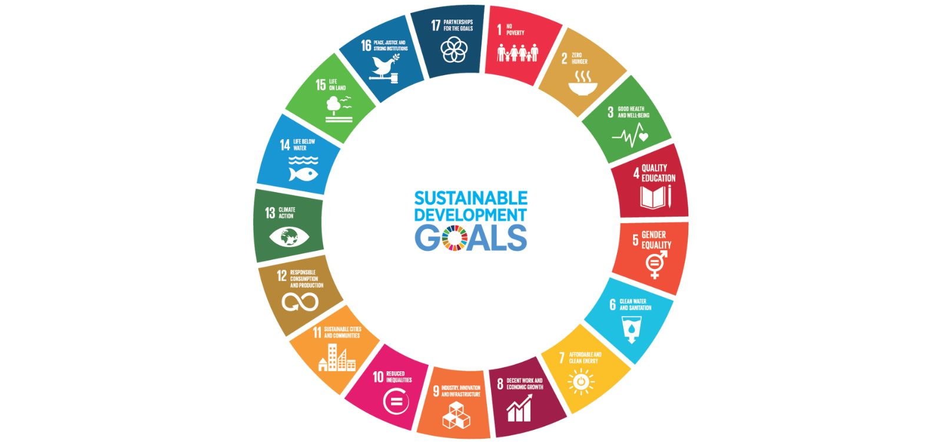
Appendix B - United Nations Sustainable Development Goals
The 2030 Agenda for Sustainable Development, adopted by all United Nations (UN) member states in 2015, provides a shared blueprint for peace and prosperity for people and the planet, now and into the future.

At its heart are the 17 Sustainable Development Goals (SDGs), which are an urgent call for action by all developed and developing countries in a global partnership. They recognise that ending poverty and other deprivations must go together with strategies that improve health and education, reduce inequality, and spur economic growth – all while tackling climate change and working to preserve our oceans and forests.

Today, the Division for Sustainable Development Goals (DSDG) in the United Nations Department of Economic and Social Affairs (UNDESA) provides substantive support and capacity-building for the SDGs and their related thematic issues.

Today, the Division for Sustainable Development Goals (DSDG) in the United Nations Department of Economic and Social Affairs (UNDESA) provides substantive support and capacity-building for the SDGs and their related thematic issues.

It includes water, energy, climate, oceans, urbanization, transport, science and technology, the Global Sustainable Development Report (GSDR), partnerships, and Small Island Developing States.

DSDG plays a key role in the evaluation of the UN systemwide implementation of the 2030 Agenda and advocacy and outreach activities relating to the SDGs. To make the 2030 Agenda a reality broad ownership of the SDGs must translate into a strong commitment by all stakeholders to implement the global goals. DSDG aims to help facilitate this engagement.
Source: https://sustainabledevelopment.un.org

Table 04 - Sustainable Development Goals
Sustainable Development Goals
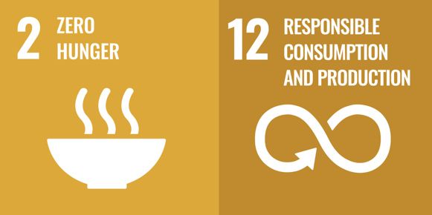 | Goal 2: End hunger, achieve food security and improved nutrition and promote sustainable agriculture  Goal 12: Ensure sustainable consumption and production patterns  Food banking’s impact does not end with SDGs 2 and 12.  Food banks promote progress across all SDGs.  While food banks are most closely associated with SDGs 2 and 12, they are also essential partners in all the SDGs.
   | Goal 1: End poverty in all its forms everywhere  Goal 4: Ensure inclusive and equitable quality education and promote lifelong learning opportunities for all  Food banks support school feeding and other child hunger programs that contribute to SDG 2, but research shows that school feeding programs also help reduce poverty (SDG 1) and improve education outcomes (SDG 4).
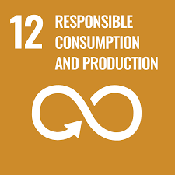   | SDG12. Target 12.6 Encourage companies to adopt sustainable practises and sustainability reporting.  We WILL provide Sustainability Reporting to clients, quantifying their scope 3 emissions, and facilitating ESG waste reporting at a board level.  Goal 13: take urgent action to combat climate change and its impacts  SDG13. Climate Action: Food banks are key to achieving SDG12, Responsible Consumption and Production which is a critical driver to achieving SDG 13, Climate Action.
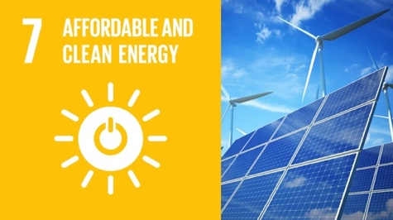 | Target 7.2 – Increase the Global Percentage of Renewable Energy  By 2030, increase substantially the share of renewable energy in the global energy mix.

Appendix C – Carbon Offset
A carbon offset is a certificate that represents one tonne of CO₂e reduction in the atmosphere. The purchase of carbon offsets for emissions allows the financing of projects that capture and remove emissions or reduce CO₂e in the atmosphere. Carbon dioxide (CO₂e) offsetting is the process of financially supporting projects around the world that work to reduce greenhouse gas emissions.

Therefore, for an organisation to be officially carbon neutral, any emissions calculated from the event must be offset by contributing to programmes that remove carbon emissions from the atmosphere, especially those that are relevant to the organisation or geographical location.

Based on the data provided with limitations, this report assessed the total emissions of Selby Trust (General Info – 14C) at 2,079.61 Results Graphs – DASHBOARD) of CO₂e, which need to be offset to achieve Carbon Neutrality. Normally, each carbon credit accounts for one tonne of CO₂e.Ideally, the charity can offset 10% of its emissions with renewable energy projects for example. However, the other 90% relates to technologies and projects that enable the mitigation of these emissions over the years.

Selby Trust may offset its carbon emission by investing in high-quality international carbon reduction projects that provide additional benefits such as biodiversity, job creation, food security, social and environmental justice, clean drinking water and health and welfare. These projects can be classified as Gold Standard Verified Reductions (VERs), Certified Emission Reductions (CERs) and Verified Carbon Units (VCUs) credits.
Verified Carbon Standard (VCS)
The Verified Carbon Standard (VCS) is an offset certification program managed by Verra. It is widely supported, with projects worldwide. VCS is focused wholly on removing and reducing greenhouse gas (GHG) emissions, and there are strict guidelines that projects must meet to be verified under the VCS program.

The VCS issues a Voluntary Carbon Unit (VCU) to approved programs, and an awarded VCU represents the removal or reduction of one tonne of GHG emissions. These VCUs are what we purchase on the global carbon market and allocate to you when you purchase a carbon offset.

The basic criteria for an approved project include:

- Real: all GHG emission reduction or removal by the project must be proven to have genuinely taken place.
- Measurable: emissions reductions or removal must be measured and quantified using accurate measurement methods against a credibly established baseline.
- Additionally: all GHG removals and reductions should be over an established baseline to ensure that any removals or reductions are because of the project being in place.
- Conservative: in case of any uncertainty in measurement, lower values will be recorded and used to ensure there is no overestimation of VCUs.
- Independently audited: an accredited team with experience in the relevant field and country needs to verify all GHG emission reductions and removals.
- Transparent: all data collected and recorded should be appropriately disclosed to the public so that users can make informed decisions with confidence. This information about each project is available in the Verra Project registry, along with a list of all VCS-certified projects.
- Unique: each VCU should be unique and should be linked to a single project or activity. No removal or reduction of GHGs should be double-counted, and no VCU can be double-claimed.
- Permanent: if there is any risk of reversibility of the GHG removed or reduced, the project should have processes in place to ensure any reversal is compensated for.

These comprehensive criteria ensure that only genuine projects that have a meaningful impact on greenhouse gas emissions are approved under the Verified Carbon Standard.

Potential offset project from Verified Carbon Standard (VCS):

Table 04 - Selby Trust and the Sustainable Development Goals
Project name | Housing Decarbonisation in the UK
Project description | This project facilitates the decarbonisation of housing stock in the United Kingdom. Emission reductions are generated by reductions in fossil fuel consumption in dwellings that are decarbonised compared to baseline consumption. The aggregated emissions from fossil fuel consumption of dwellings in the United Kingdom make up a significant component of greenhouse gas emissions; they also pose a significant opportunity to reduce real emissions.
Link | https://registry.verra.org/app/projectDetail/VCS/2649

Gold Standard Verified Reduction (VERs)
The Gold Standard was developed in 2003 by the Worldwide Fund for Nature (WWF). It is an international offset program administered by the Gold Standard Foundation based in Geneve, Switzerland. Compared to the VCS, the Gold Standard has additional requirements when certifying a project. The requirements for a Gold Standard certification are:

- The project should reduce or remove one of the three eligible GHGs: methane, carbon dioxide, and nitrous oxide. The measurement of this removal has similar criteria to that of the VCS outlined above.
- The project should be achieving its goal by supplying renewable energy, reducing end-user energy usage, afforestation, reforestation, or agriculture.
- The project should not be applying for another certification to prevent double counting.
- The additional GHG emission reduction or removal should be documented and should be occurring because of the project.
- The project should be contributing to at least three of the Sustainable Development Goals (Appendix B).

The final assessment criterium is particularly important. It means that in addition to reducing or removing GHG emissions, a Gold Standard-certified project also benefits the local population’s financial, social, and environmental outcomes.

Potential offset projects from Gold Standard Renewable Energy Projects (VERs) are presented below.

Table 06- Gold Standard Projects
Project Name | 100 MW solar power plant in Maharashtra, India | Biodiverse forest plantation in Panama | Ceará renewable energy project, Brazil
Project description | Juniper Green Energy Pvt. Ltd. and its 100% subsidiary Nisagra Renewable Energy Pvt. Ltd. have together setup a 100 MW Solar power project in the state of Maharashtra, India. Out of 100 MW, Juniper Green Energy Pvt. Ltd. has setup 30 MW (10x3) project while the 70 MW (10x7) project has been setup by Nisagra Renewable Energy Pvt. Ltd. The projects feed the power generated directly into dedicated agricultural feeders. It has played an important role in reducing CO2 emissions by generating 240 GWh of clean electricity annually, which is equivalent to powering 56,000 households every year. | The project, initially developed by Forest Finance and recently extended by the partner Sustainable Timber and Isla Cebaco, is based on a model that combines sustainable, high-quality timber production with biodiversity protection and ecosystem restoration. By also planting a mix of cacao and native tree species in some areas, the project also enables sustainable cacao production. | Based in a region prone to poverty and severe drought, this initiative tackles one of the major causes of deforestation in Brazil: illegal logging. The Ceará project has switched the fuel used by five ceramic factories from illegal firewood to agricultural and industrial residues. This biomass would have otherwise been discarded as waste, so the fuel switch not only transforms residues into something useful but also enables many local individuals to make a living - or complement their income – by supplying biomass waste directly to the factories.
Link | https://marketplace.goldstandard.org/collections/projects/products/infinite-solutions-100-mw-solar-power-plant-in-maharashtra | https://marketplace.goldstandard.org/collections/projects/products/planting-biodiverse-forests-panama | https://marketplace.goldstandard.org/collections/projects/products/ceara-renewable-energy-bundled-project

Ultimately, choosing offsets that are certified under the VCS or the Gold Standard makes sure that your contribution is having a meaningful impact on climate change.

Both standards are widely trusted, being developed by experts and expanding upon standards employed by the United Nations Clean Development Mechanism. The standards are also widely used in mandatory carbon compliance markets, meaning that governments and regulators use these mechanisms of measurement and management to enforce carbon offset laws. This goes to show how well these certifications have been structured.

When offsetting your carbon emissions, be sure to partner with an organization that you can trust. By partnering with Verra and the Gold Standard, organisations guarantee that every project they support is held to the strictest of standards.

Appendix D – Emissions Sources Classification

GHG Protocol | Emission Source | ISO 14064-1 | SBTi Relevance
Scope 1 – Stationary combustion | Natural gas for facilities | Direct Emissions (A) | Always included in targets
Scope 1 – Mobile combustion | Company fleet & operated leased vehicles | Direct Emissions (A) | Always included
Scope 2 | Electricity use | Indirect Energy Emissions (B) | Always included
Scope 3 – Cat. 6 | Private vehicle for business use | Other Indirect (C) | Included if Scope 3 >=40%
Scope 3 – Cat. 6 | Business travel | Other Indirect (C) | Material for service companies
Scope 3 – Cat. 7 | Employee commuting | Other Indirect (C) | Included based on materiality
Scope 3 – Cat. 7 | Home working | Other Indirect (C) | Included based on materiality
Scope 3 – Cat. 3/5 | Water & wastewater | Other Indirect (C) | Usually low impact
Scope 3 – Cat. 5 | Waste | Other Indirect (C) | Typically low but reportable
Scope 3 – Cat. 1 | Purchased goods & services | Other Indirect (C) | Often largest category; critical for SBTi
Scope 3 – Cat. 2 | Capital goods | Other Indirect (C) | Relevant for SBTi
Scope 3 – Cat. 4 | Upstream transport | Other Indirect (C) | Include if material
Scope 3 – Cat. 9 | Downstream transport | Other Indirect (C) | Relevant if products shipped
Scope 3 – Cat. 11 | Use of sold products | Other Indirect (C) | Relevant for product-based companies
Scope 3 – Cat. 12 | End-of-life of products | Other Indirect (C) | Relevant for product companies
Scope 3 – Cat. 14 | Franchises | Other Indirect (C) | Relevant when applicable
Scope 3 – Cat. 15 | Investments | Other Indirect (C) | Critical for financial sector

